2020 Big Conversation of Southern MD

Many Wounds to Heal:  Health Care (In)Equity -  How Does It Affect Me? | 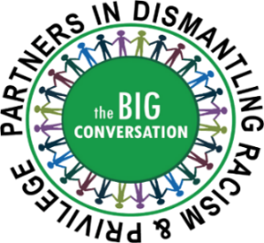

Sunday, September 13, 2020 2 - 5 pm Online
You Must Pre-register: https://bit.ly/BigConversation91320

Expert panel will address historical inequities in Southern MD healthcare, implicit bias in healthcare delivery, systemic and environmental impact on health outcomes, and lack of trust in healthcare. Panelists include:
Dr. Meenakshi Brewster – Public Health Officer – St. Mary’s County
Shellnice M. Hudson, RN – Director of Quality Assurance, Charlotte Hall Veterans Home
Dr. Laurence Polsky – Public Health Officer – Calvert County

Cheri C. Wilson, MHS – Johns Hopkins Medicine, Office of Diversity, Inclusion, and Health Equity

Malcolm Funn, JD – Calvert NAACP

Moderator: Lauretta Grier, MA – Concerned Black Women of Calvert
Followed by small group discussions online
More information: email - bigconmsp@gmail.com or website- dismantleracism.org
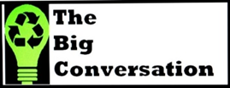

Brought to you by the founder Middleham and St.Peter’s Parish with The Big Conversation Partners in Dismantling Racism and Privilege in Southern MD including: All Saints Episcopal Church, Calvert County Public Schools, CalvertHealth, Calvert Interfaith Council, Community Mediation Centers of Calvert, Charles and St. Mary’s Counties, College of Southern Maryland, , Concerned Black Women of Calvert Co, Emmanuel SDA Church – St. Leonard, Historic Sotterley, Inc., NAACP Branches of Calvert, Charles and St. Mary’s Counties, Patuxent Friends (Quaker) Meeting, Public Libraries of Calvert, Charles, and St. Mary’s Counties, Remnant Center of Excellence, Inc., St. Mary’s Co. Health Department and St. Mary’s Co. Public Schools.

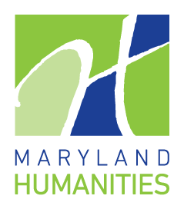 | This project was made possible in part by the Maryland Humanities, through support from the National Endowment for the Humanities, the Maryland Historical Trust in the Maryland Department of Planning, and the Maryland Department of labor. Any view, finding, conclusions, or recommendations expressed here do not necessarily represent those of the National Endowment for the Humanities, Maryland Humanities, Maryland Historical Trust, Maryland Department of Planning, or the Maryland Department of Labor.

