UNITED
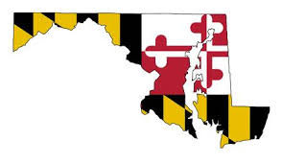
DEMOCRATIC
WOMEN OF MARYLAND

Statewide Luncheon
Saturday, September 21, 2019

Featured Speakers
BEN SMITH, Executive Director, Maryland Democratic Party
Political consultant covering field, policy, digital, and traditional media. Growing up in the rural South, Ben has a deep personal and professional connection with rural communities and rural voters. He knows what we’re up against on the Eastern Shore!

Senator SARAH ELFRETH, Legislative District 30, Anne Arundel
Strengthening communities with focus on environmental challenges, jobs in renewable energy, gun safety, public education. Sits on Tristate Chesapeake Bay Commission.

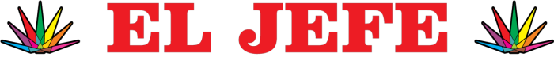

1235 Shopping Center Rd
Stevensville, MD 21666
(north side of Rte. 50, near the Bay Bridge)
410-604-1234

RSVP by September 13, 2019 to Jody Oliver: jodyjolliver@gmail.com

$25.00 in advance
$30.00 at the door

By mail: Jody Oliver, 635 Arundel Street, Cumberland, MD 21502
Online: udwmd.com (link to PayPal)

MEETING AGENDA

10:00 Executive Board Meeting
11:00 General Meeting (doors open 10:45 for general meeting attendees)
12:00 Lunch
12:30 Speakers

Questions? Marion Grier (kmgrier@gmail.com) or Denise Riley (rileyd1@hotmail.com)

